**Stock Market Data Analysis for INFOSYS, TCS & WIPRO**

Average Volatility Calculation

Formula 🡪Average(Day High – Day Low) over a period of time

**Lower the Volatility the better**

WIPRO has minimum volatility and TCS has maximum volatility

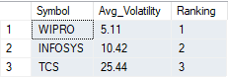

Drawdown / Fall in Stock Price

Formula 🡪 % Increase = (Final Value – Initial Value) / Initial Value × 100

**Lower the Drawdown the better**

🡪Created a view containing the data of Closing stock price between 2020 Feb to 2020 March (Covid Period) for all 3 companies -

drop view if exists A3

create view A3 as(select Date, Symbol, [Close] from Infosys where Date between '2020-02-01' and '2020-03-31' and [Close] is not null

union

select Date, Symbol, [Close] from [TATA CONSULTANCY SERVICES] where Date between '2020-02-01' and '2020-03-31' and [Close] is not null

union

select Date, Symbol, [Close] from WIPRO where Date between '2020-02-01' and '2020-03-31' and [Close] is not null)

select * from A3

🡪Calculated the Drawdown along with the max and min Closing Stock Price for each company -

select Symbol,MAX([Close]) as Max_Close,MIN([Close]) as Min_Close, round((MIN([Close])-MAX([Close]))/MAX([Close]),4)*100 as Drawdown

from A3

group by Symbol

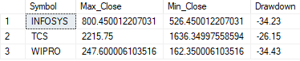

WIPRO has the maximum Drawdown and TCS has the minimum Drawdown

Recovery Days (Post Covid Fall)

The number of days taken by the stocks after its fall to again close above its peak value.

**Lower the number of Recovery Days taken the better**

🡪Created a view containing the data and calculating the date when the stock price went above its peak for the first time after its depression

drop view if exists A4

create view A4 as(

select Date,Symbol from

(select Date,Symbol,[Close],row_number() over(order by Date asc) as Date_Number_MaxCloseRecovered

from INFOSYS

where Date between '2020-03-23' and '2021-03-31' and [Close]>=(select max([Close]) from A3 where Symbol='INFOSYS')

union

select Date,Symbol,[Close],row_number() over(order by Date asc) as Date_Number_MaxCloseRecovered

from [TATA CONSULTANCY SERVICES]

where Date between '2020-03-19' and '2021-03-31' and [Close]>=(select max([Close]) from A3 where Symbol='TCS')

union

select Date,Symbol,[Close],row_number() over(order by Date asc) as Date_Number_MaxCloseRecovered

from WIPRO

where Date between '2020-03-19' and '2021-03-31' and [Close]>=(select max([Close]) from A3 where Symbol='WIPRO')) as D

where D.Date_Number_MaxCloseRecovered=1)

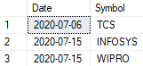

🡪Converted the view into a temp table as we cannot add a new column in a view. After creating the temp table we added a new column storing the dates when the stock price was the lowest.

select *

into #temptable

from A4

alter table #temptable

add Min_Close_Date Date

select* from #temptable

update #temptable set Min_Close_Date = '2020-03-23' where Symbol = 'INFOSYS'

update #temptable set Min_Close_Date = '2020-03-19' where Symbol = 'TCS'

update #temptable set Min_Close_Date = '2020-03-19' where Symbol = 'WIPRO'

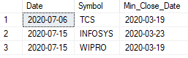

🡪Calculated the number of recovery days using Datediff function. (Min_Close_Date – Date)

select Symbol, Date, Min_Close_Date, DATEDIFF(day,Min_Close_Date,Date) as Recovery_Days_Number from #temptable

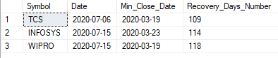

TCS has the minimum number of recovery days. So it recovered from the covid fall the fastest. WIPRO has the max number of recovery days.

Strength

The number of days when stock price closed above its previous day closing price.

**Higher the Strength the better**

🡪At first we created a view consisting the previous closing price brought using LAG function

drop view if exists A5

create view A5 as(select Symbol, Date, [Close],LAG([Close]) over (order by Date) as Prev_Day_Close from INFOSYS where [Close] is not null

union

select Symbol, Date, [Close],LAG([Close]) over (order by Date) as Prev_Day_Close from [TATA CONSULTANCY SERVICES] where [Close] is not null

union

select Symbol, Date, [Close],LAG([Close]) over (order by Date) as Prev_Day_Close from WIPRO where [Close] is not null)

select * from A5

🡪Then we counted the number of days when Close > Prev_Day_Close

select Symbol,sum(case when [Close]>Prev_Day_Close then 1 else 0 end) as Strength,RANK() over (order by sum(case when [Close]>Prev_Day_Close then 1 else 0 end) desc) as Ranking

from A5

group by Symbol

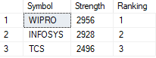

WIPRO has the max strength and TCS has the min strength

CAGR (Compound Annual Growth Rate)

It is the rate of return that would be required for an investment to grow from its beginning to its ending balance, assuming the profits were reinvested at the end of each period of investment’s life span.

Formula 🡪 CAGR = ((EV/BV)1/n – 1) × 100

Where EV = Ending Value, BV = Beginning Value, n = Number of years

**Higher the better**

In the data, Starting Date : 2002-08-13 Ending Date : 2023-06-22 (where data is present in all 3 tables with non-null close values)

🡪At first we created a view consisting the Close data of the Starting and Ending dates of the companies

drop view if exists A6

create view A6 as (Select [Close], Symbol from A5 where Date='2002-08-13'

union

Select [Close], Symbol from A5 where Date='2023-06-22')

select* from A6

🡪Then using self-join we segregated the starting and ending dates into separate columns. We also calculated the number of years. We stored the result in a temp table

select *

into #temptable1

from

(select t1.Symbol,t2.[Close] as End_Date_Close,t1.[Close] as Start_Date_Close, ROUND(datediff(day,'2002-08-13','2023-06-22')/365.0,3) as No_of_Years

from A6 t1,A6 t2

where t2.Symbol=t1.Symbol and t2.[Close]>t1.[Close]) as t

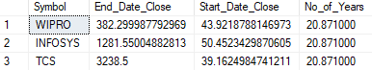

🡪Then from the temp table we calculated the CAGR

select Symbol, ROUND((power((End_Date_Close/Start_Date_Close),(1/No_of_Years))-1)*100,3) as CAGR

from #temptable1

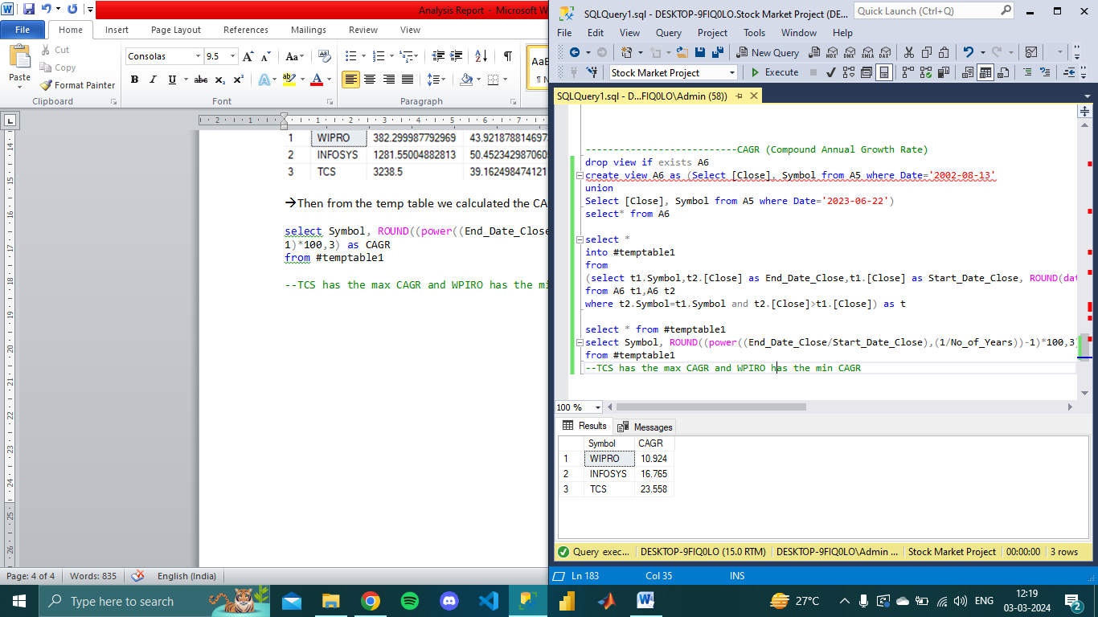

--TCS has the max CAGR and WPIRO has the min CAGR

Months where Volume was the Highest

Volume refers to the total number of shares of a company traded in a specific time frame.

select * from

(select top 1 Symbol,YEAR(Date) as Year,MONTH(Date) as Month,MAX(Volume) as Max_Volume

from INFOSYS

group by Symbol,YEAR(Date),MONTH(Date)

order by MAX(Volume) desc

union

select top 1 Symbol,YEAR(Date) as Year,MONTH(Date) as Month,MAX(Volume) as Max_Volume

from [TATA CONSULTANCY SERVICES]

group by Symbol,YEAR(Date),MONTH(Date)

order by MAX(Volume) desc

union

select top 1 Symbol,YEAR(Date) as Year,MONTH(Date) as Month,MAX(Volume) as Max_Volume

from WIPRO

group by Symbol,YEAR(Date),MONTH(Date)

order by MAX(Volume) desc) as p

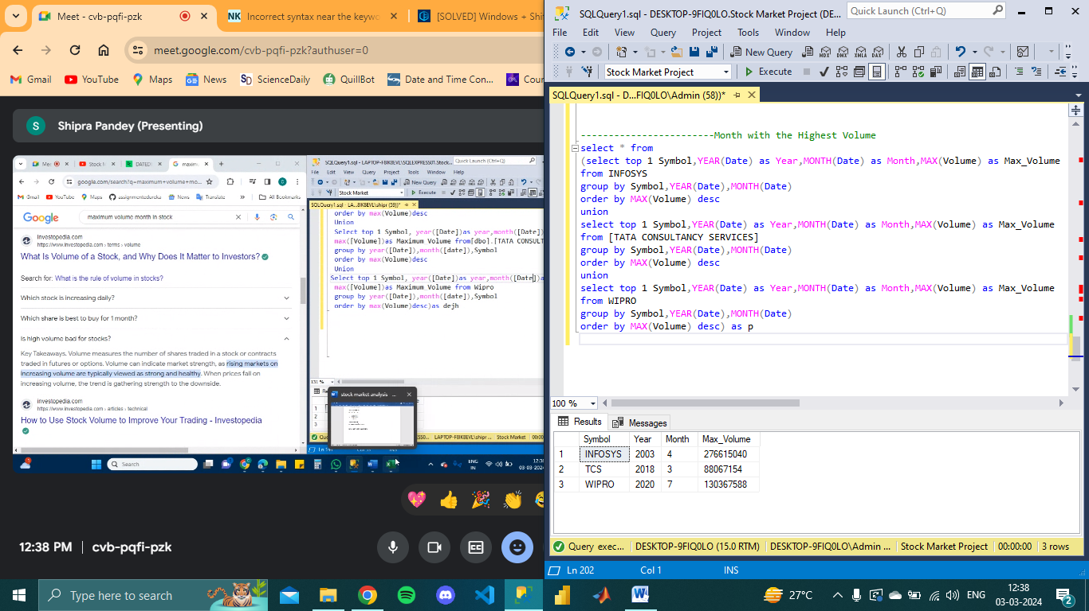

**Final Ranking Table**

|  |  |  |  |  |  |
| --- | --- | --- | --- | --- | --- |
| Symbol | Volatility | Drawdown | Recovery | Strength | CAGR |
| TCS | 3 | 1 | 1 | 3 | 1 |
| INFOSYS | 2 | 2 | 2 | 2 | 2 |
| WIPRO | 1 | 3 | 3 | 1 | 3 |